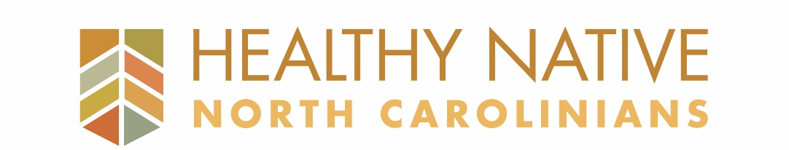

2019-2020 Application

Below is the application for funding for the 2019-2020 iteration of Healthy Native North Carolinians (HNNC) administered by the UNC American Indian Center (AIC). Once complete, this form should be emailed to rrbyrd@email.unc.edu no later than May 6th, 2019, 11:59pm EDT and must be accompanied by a W-9 form. Incomplete applications and applications submitted after the deadline will not be accepted. Tribes and/or organizations will be contacted by May 15th, 2019 with a final funding decision.
- CONTACT INFORMATION
Tribe or Organization: _______________________________________________________________________________________________
Tribe/Organization Address: __________________________________________________________________________________________
Primary Tribe/Organization Contact: ____________________________________________________________________________________
Title/Role: ______________________________________________________
Email: _____________________________________________Phone:__________________________________________________________
Primary Project Contact: ______________________________________________________________________________________________
Title/Role: _______________________________________________________
Email: _____________________________________________ Phone: _________________________________________________________
List of counties served by your project: ___________________________________________________________________________________

- PROPOSAL SUMMARY Please provide no more than a paragraph for each bullet point. You will be able to describe your activities in more detail in the chart in section C.

- Please provide a brief summary of the intended impact of your proposal (be sure to include which health and wellness challenges you will be addressing as well as the Priority Focus Areas (see the Request for Proposals) – applicants can choose one or more focus areas).

- What activities are you committed to carrying out?

- What strategies will you use to ensure you are making progress throughout the grant period?

- What strategies will you use to measure the overall impact of your activities?

- PROPOSED ACTIVITIES In the table below, please provide the name of your proposed activity(ies), description of activity(ies), parties responsible and parties impacted, and when activities will take place. You can use as few or as many lines as needed. Example provided in Section E.

Name of Activity | Description of Activity | Who is carrying out the activity? Who is impacted? | When?  Can be a month, season, specific date (if known) or ongoing.

- BUDGET
Tribe or Organization: ____________________________________________________________________
Project Expenses  Please provide a detailed list of itemized expenses for each category. Example provided in Section E. | Amount
YEAR 1
PERSONNEL
SUPPLIES & MATERIALS
EQUIPMENT
OTHER PROGRAM EXPENSES
PRINTING, MAILING & MARKETING
TRAVEL
YEAR 1 TOTAL | $9,000

YEAR 2
PERSONNEL
SUPPLIES & MATERIALS
EQUIPMENT
OTHER PROGRAM EXPENSES
PRINTING, MAILING & MARKETING
TRAVEL
YEAR 2 TOTAL | $9,000
GRAND TOTAL (YEAR 1 +YEAR 2) | $18,000
Please see the budget example the AIC has provided below with explanation of detail required.

- TABLE & BUDGET EXAMPLES
